

**Superior University Gold Campus**

**PAI Lab Task #7**

Name: Syed Ejiz Ul Hassan Kazmi

Roll. No: SU92-BSDSM-F23-025

Section: BSDS-4A

Instructor: Sir Rasikh Ali

### ****Vehicle Info App****

### Introduction

This Vehicle Info App is a simple Python-based command-line tool that interacts with a **free API** from the **National Highway Traffic Safety Administration (NHTSA)**. It helps users get information about vehicles either by entering the **vehicle make** (e.g., Toyota) or a **VIN (Vehicle Identification Number)**.

**Features**

* Fetch vehicle models based on manufacturer (make)
* Get full vehicle details by entering a valid VIN
* User-friendly terminal interface
* Uses publicly available NHTSA API (no API key required)
* Real-time data retrieval from official sources

### Code Explanation

### Imports:

### We import the requests library to send HTTP GET requests to the NHTSA API.

#### **Function: get_models_by_make(make)**

* Takes vehicle **make** as input.
* Calls API to get all models for that make.
* Displays results in a list.

#### **Function: get_vehicle_by_vin(vin)**

* Takes vehicle **VIN** as input.
* Calls API to decode the VIN and show detailed information like make, model, engine, year, etc.

#### **Function: main()**

* Displays a menu:
  1. Get Models by Make
  2. Get Vehicle Info by VIN
  3. Exit
* Calls appropriate functions based on user input.
* Runs in a loop until the user chooses to exit.

### Sample Data

**Sample VIN:**  
1HGCM82633A004352  
(2003 Honda Accord EX)

**Output:**

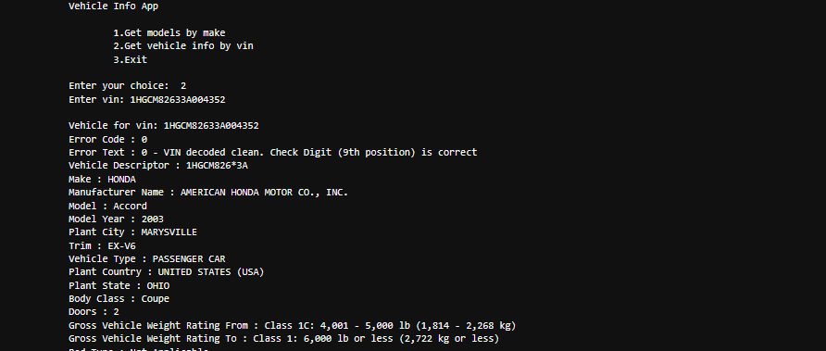

**Valid Vehicle Makes:**  
Toyota, Honda, Ford, BMW, Audi, Nissan, Chevrolet, Kia, Hyundai, Tesla

**Use Cases**

* Students learning how to use APIs in Python
* Car dealerships or resellers verifying vehicle data
* Vehicle registration systems for quick VIN decoding
* Hobby projects related to vehicles or transport apps

**_______________________________________________**